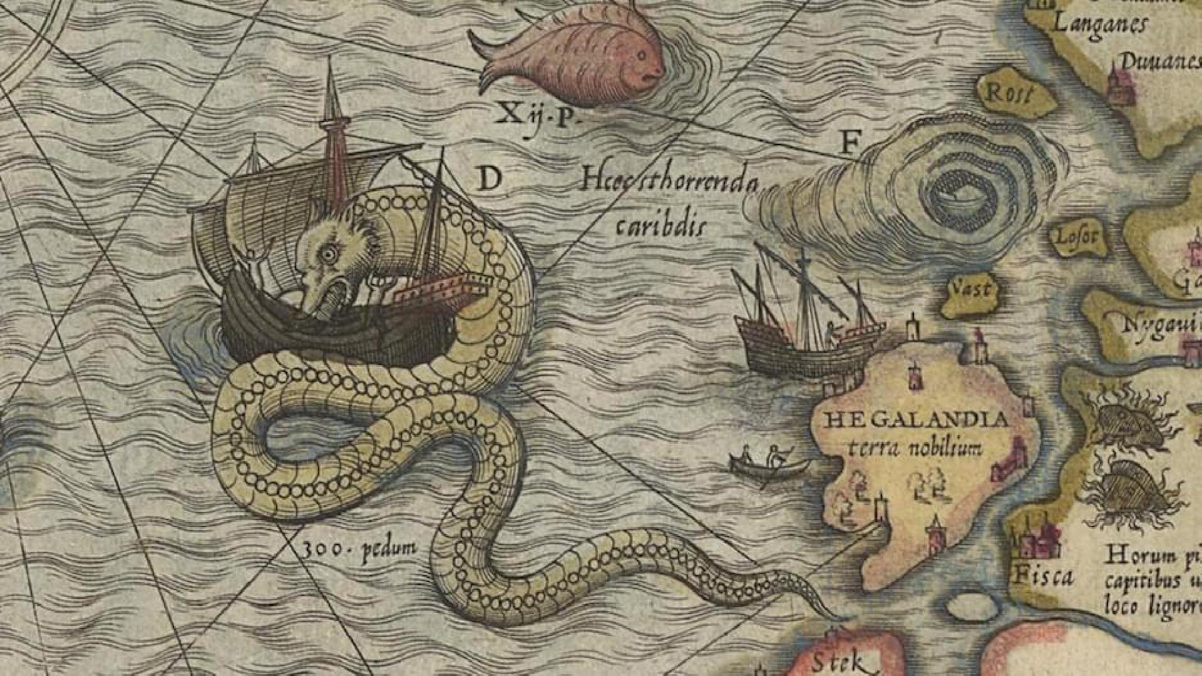

|  |
| --- |
| Myriad Worlds Developer  2018 |
| Your worlds are a Myriad of possibilities. |
| **January 18**  Fenix Technologies  Authored by: Jamison Stramer |



# Myriad Worlds Developer

|  |
| --- |
| Who we are Dare to create world. A world that is living, one that moves, flows and molds to your own whim. Let your friends explore the lands and seas of your mind; skies where dragons are the norm, ancient spells whose runes are set to be rediscovered, mysterious secrets inside cities of bronze and steam. Develop or borrow rules of all kinds to fit what you have dreamed. Myriad Worlds Developer easily stores, collects and enables you mold realities, birth heroes and villains, and craft the greatest stories one could even imagine. Your worlds are a Myriad of possibilities.  Myriad Worlds Developer aims to become a staple in the tabletop gaming community. Our goal is to aid players of all experience levels in any and all tabletop games. Myriad Worlds has the capability to create and store characters, plan and modify maps, and develop and write custom rule books. By using these (and more) tools every player from the dungeon master to the first-time role player will be able to keep track of every stat they wish to know in a fully-customizable character sheet. |